Supervised Learning Algorithms Part 1
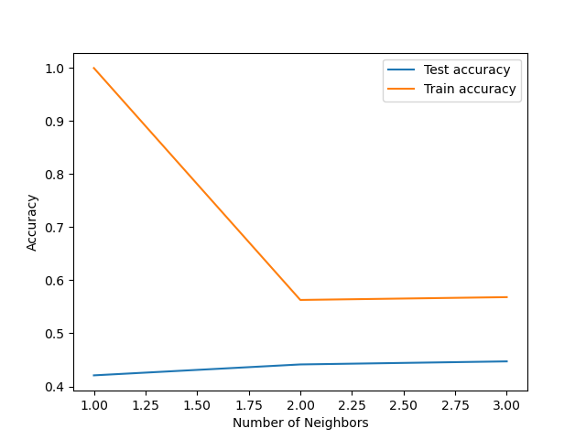
When using the k_range = np.arange(1,4) there was an interesting dip in the chart. I interpreted this as the training accuracy trying to find where things stabilize but found itself at about 56%. The test accuracy was even lower at 43%. Inspecting the confusion matrix for the same k_range provided interesting answers. Given that we can look at each station there are various conclusions for each. Sonnblick obviously had no real predictions as its entire block reads 5738. Belgrade, Budapest and Madrid all exhibit higher non-accurate readings. The confusion matrices that provide more black and dark purple in their interpretations offer more accuracy. I don’t believe there is one such weather station contributing to accuracy over another.

*confusion matrix attached separately*

